# Hive Project

Commands and their outputs

ACID PROPERTY IN HIVE

---------------------

set hive.support.concurrency = true;

set hive.enforce.bucketing = true;

set hive.exec.dynamic.partition.mode = nonstrict;

set hive.txn.manager = org.apache.hadoop.hive.ql.lockmgr.DbTxnManager;

set hive.compactor.initiator.on = true;

=> create table enquiry(Name string, Age int,Email string,Phone string,Course string,Fee int,Discount int,Demo string,Status string) clustered by (Course) into 5 buckets stored as orc tblproperties('transactional'='true');

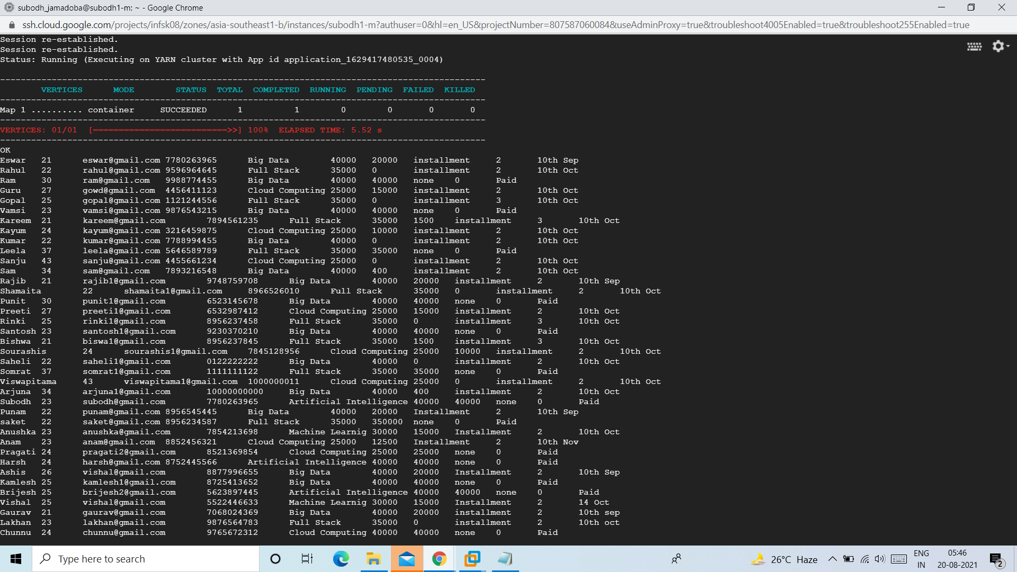

=>create table master(Name string, Age int,Email string,Phone string,Course string,Fee int,Discount int,Demo string,Status string) row format delimited fields terminated by ',' stored as textfile;

load data local inpath 'Master.txt' overwrite into table master;

insert into table enquiry select * from master;

Select * from enquiry;

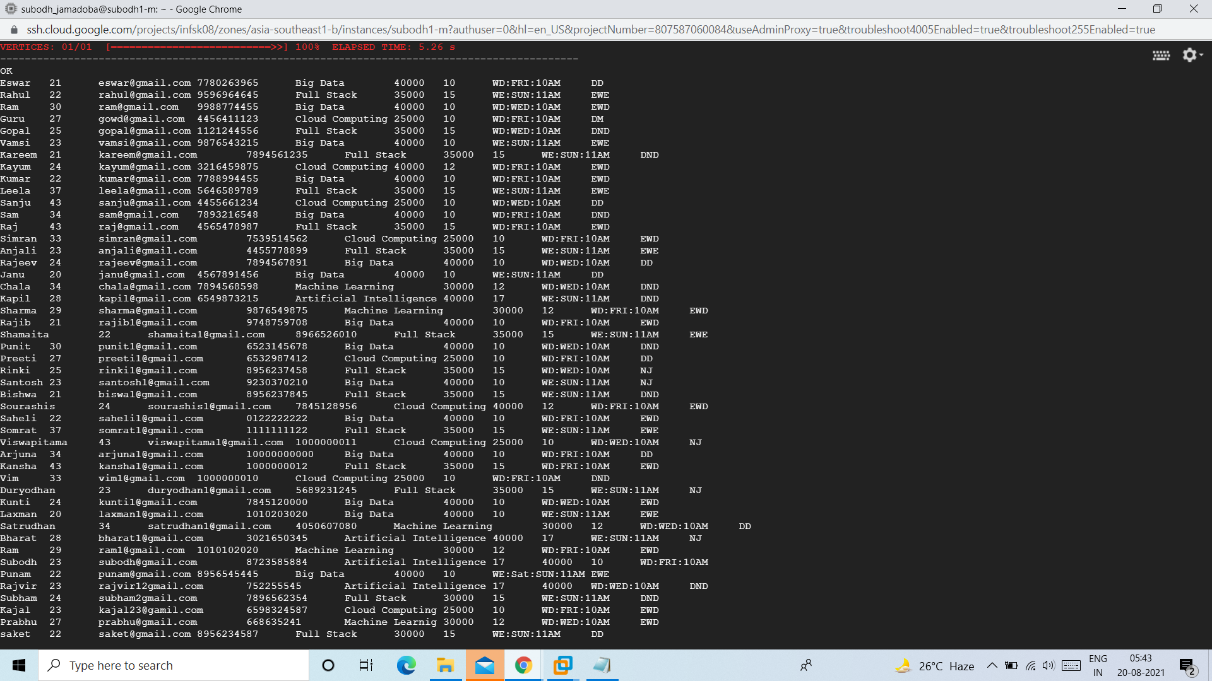

=>create table weekday_demo(name string,age int,email string,phone string,course string,demo_day string,demo_time string) clustered by (course) into 5 buckets stored as orc tblproperties('transactional'='true');

insert overwrite table weekday_demo select name,age,email,phone,course,substr(demo,4,3) as demo_day,substr(demo,8,4) as demo_time from enquiry where substr(demo,1,2)=='WD';

Select * from weekday_demo;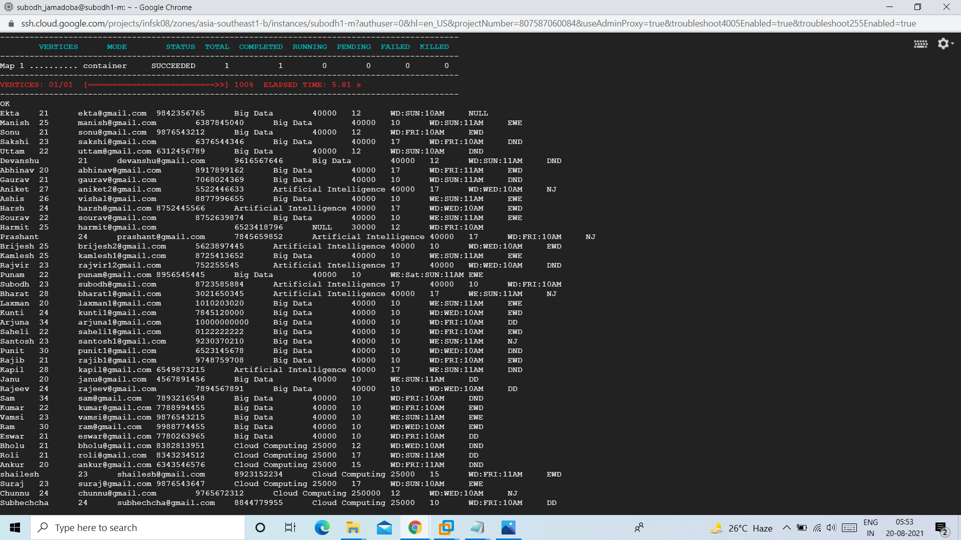

create table weekend_demo(name string,age int,email string,phone string,course string,demo_day string,demo_time string) clustered by (course) into 5 buckets stored as orc tblproperties('transactional'='true');

insert overwrite table weekend_demo select name,age,email,phone,course,substr(demo,4,3) as demo_day,substr(demo,8,4) as demo_time from enquiry where substr(demo,1,2)=='WE';

Select * from weekend_demo;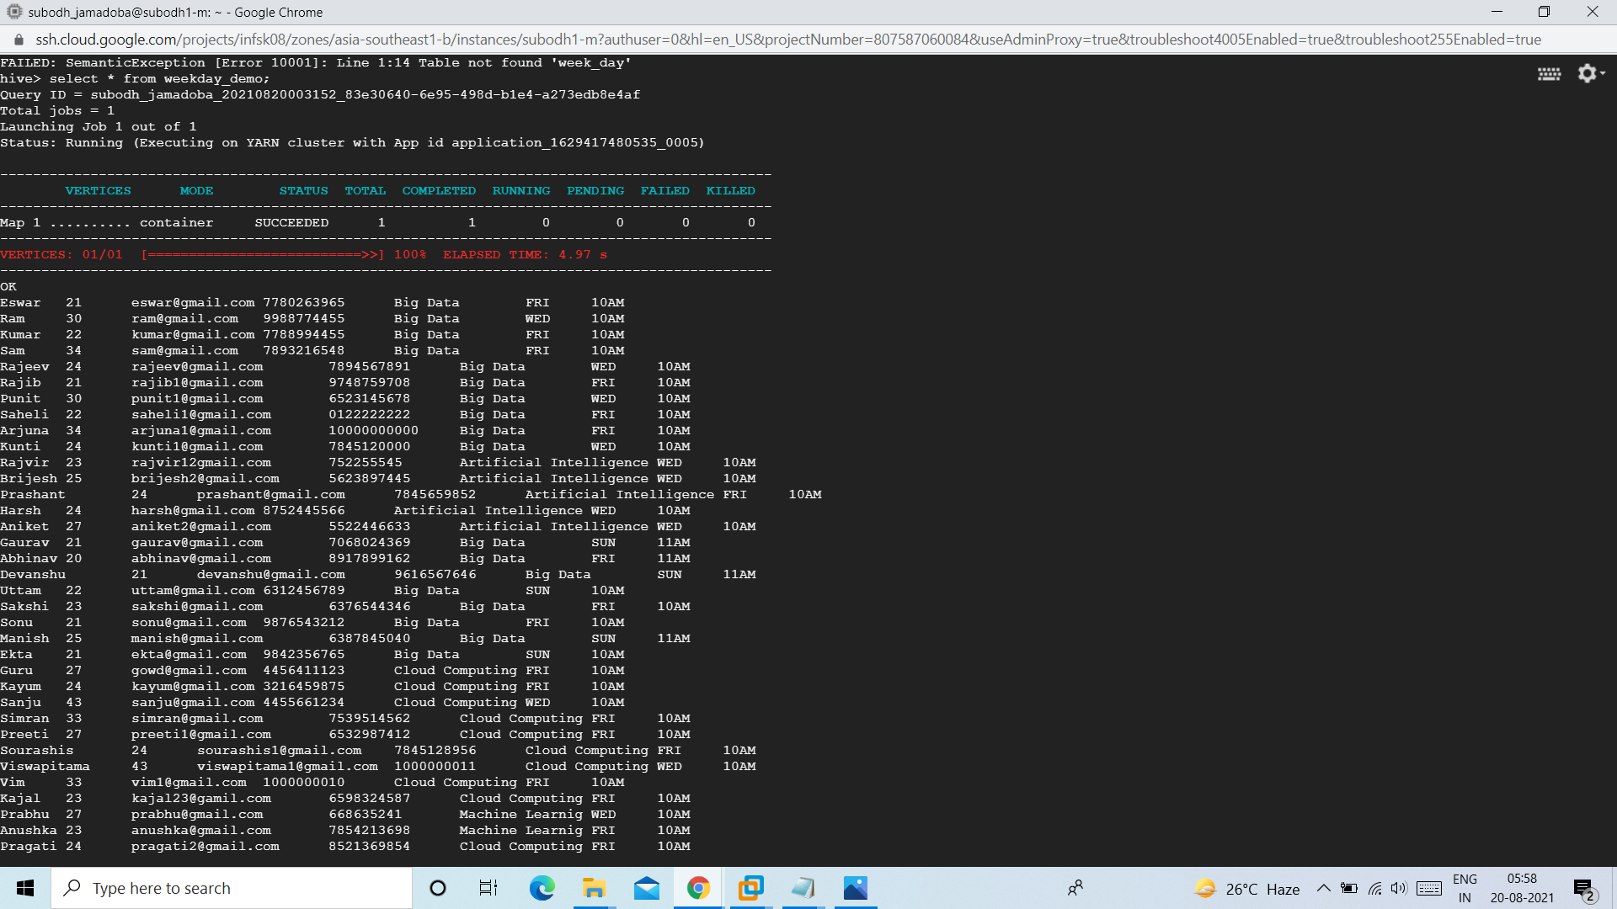

create table demo_not_done(name string,age int,email string,phone string,course string,week string,demo_day string,demo_time string) clustered by (course) into 5 buckets stored as orc tblproperties('transactional'='true');

insert overwrite table demo_not_done select name,age,email,phone,course,case when substr(demo,1,2)=='WD' then 'WEEKDAYS' when substr(demo,1,2)=='WE' then 'WEEKEND' end,substr(demo,4,3) as demo_day,substr(demo,8,4) as demo_time from enquiry where status='DND';

Select * from demo_not_done;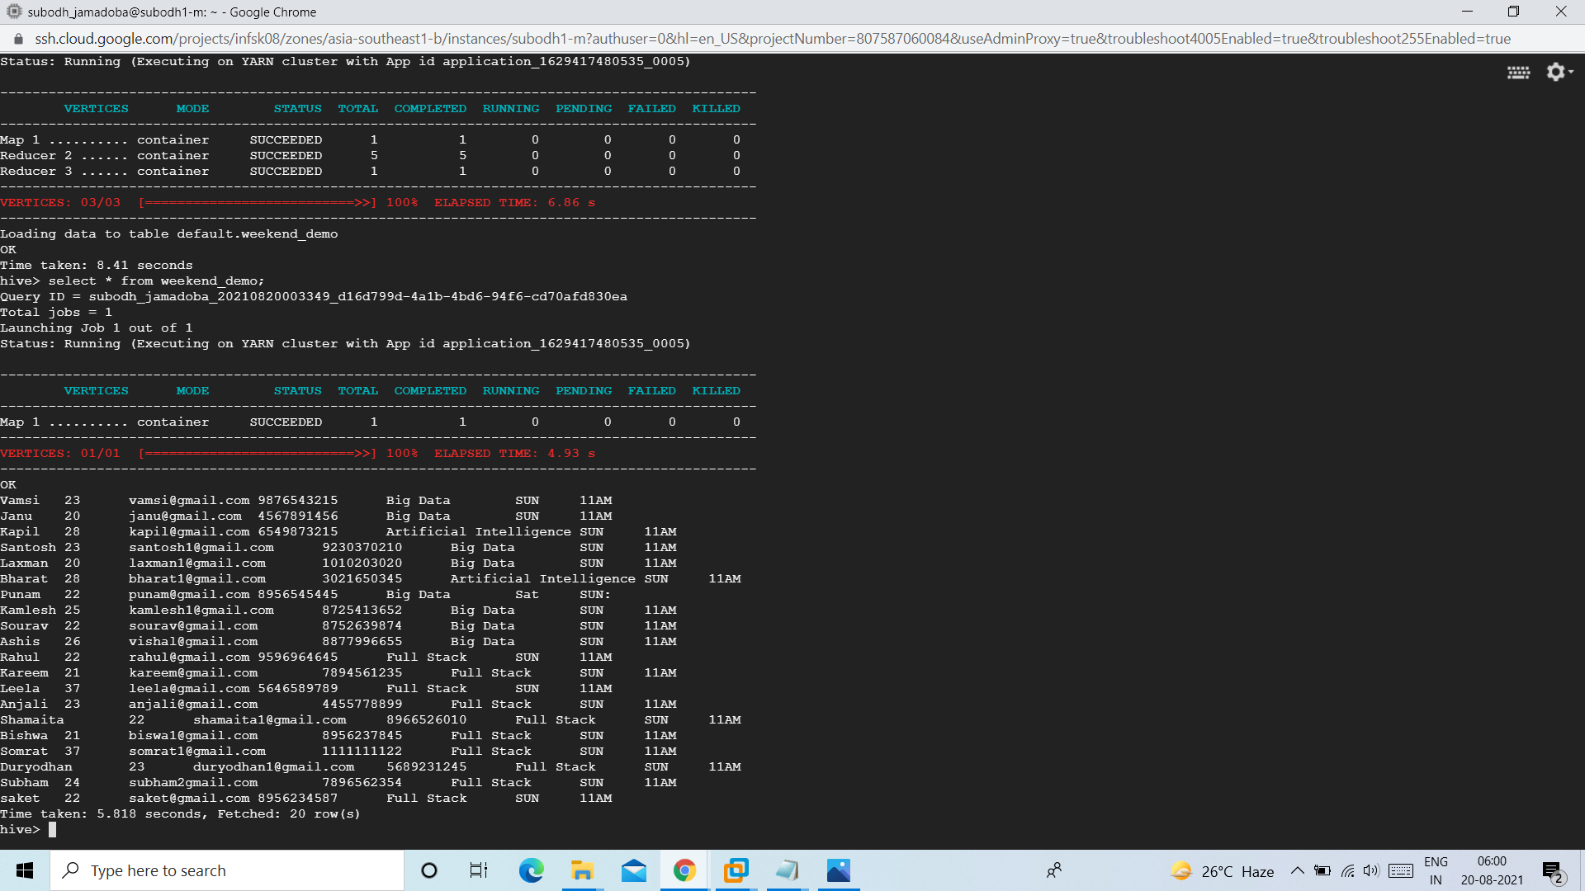

=>create table weekdays_joining(name string,age int,email string,phone string,course string,fee int,discount int) clustered by(course) into 5 buckets stored as orc tblproperties('transactional'='true');

insert overwrite table weekdays_joining select name,age,email,phone,course,fee,discount from enquiry where status='EWD';

Select * from weekdays_joining;

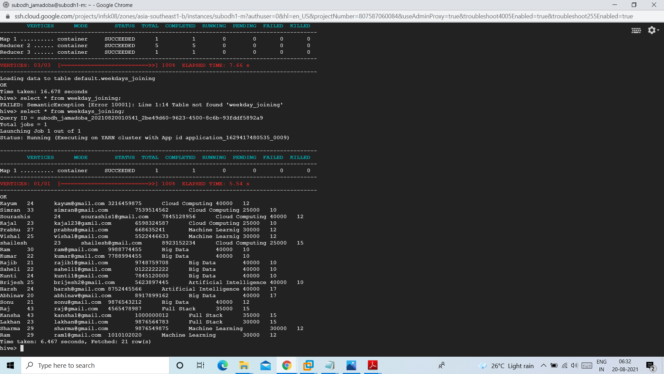

=>create table weekend_joining(name string,age int,email string,phone string,course string,fee int,discount int) clustered by(course) into 5 buckets stored as orc tblproperties('transactional'='true');

insert overwrite table weekend_joining select name,age,email,phone,course,fee,discount from enquiry where status='EWE';

Select * from weekend_joining;

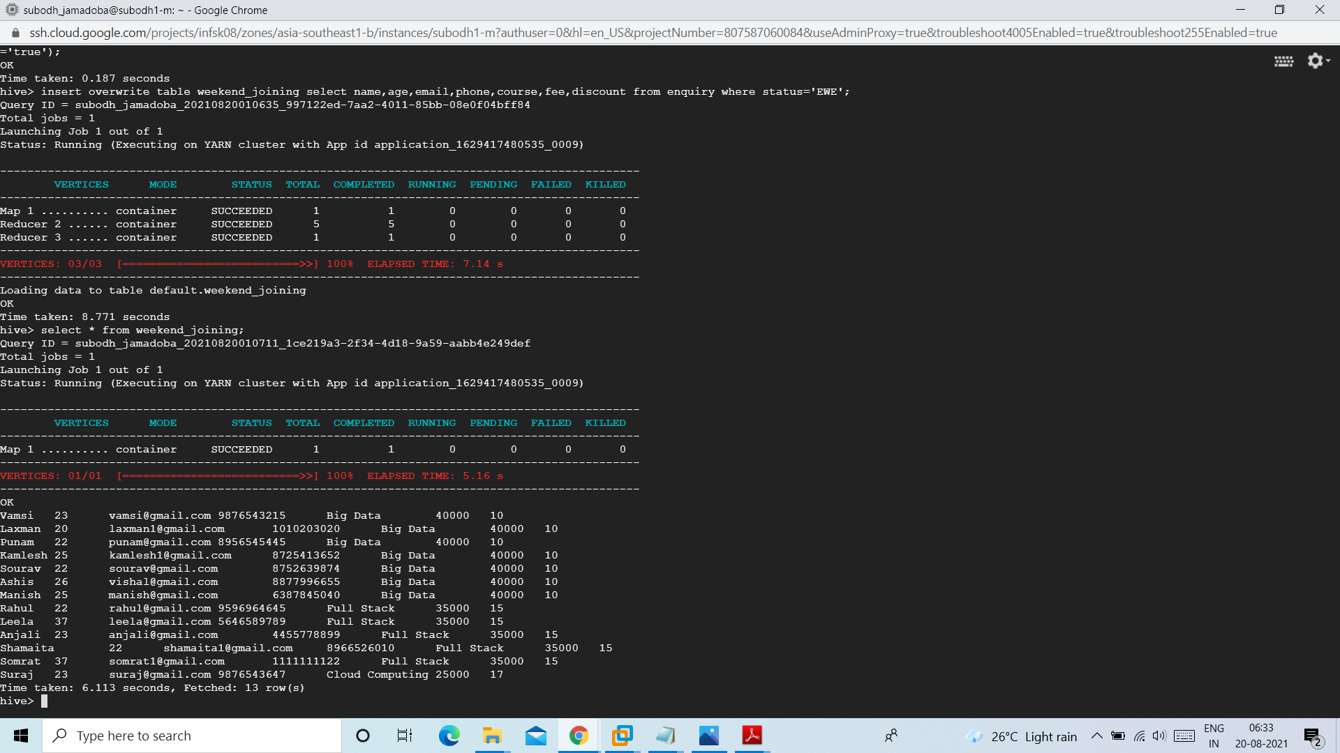

=>

create table not_joined(name string,age int,email string,phone string,course string,fee int,discount int,type string) clustered by(course) into 5 buckets stored as orc tblproperties('transactional'='true');

insert overwrite table not_joined select name,age,email,phone,course,fee,discount,case when substr(demo,1,2)=='WD' then 'Weekdays' else 'Weekend' end from enquiry where status='NJ';

Select * from not_joining;

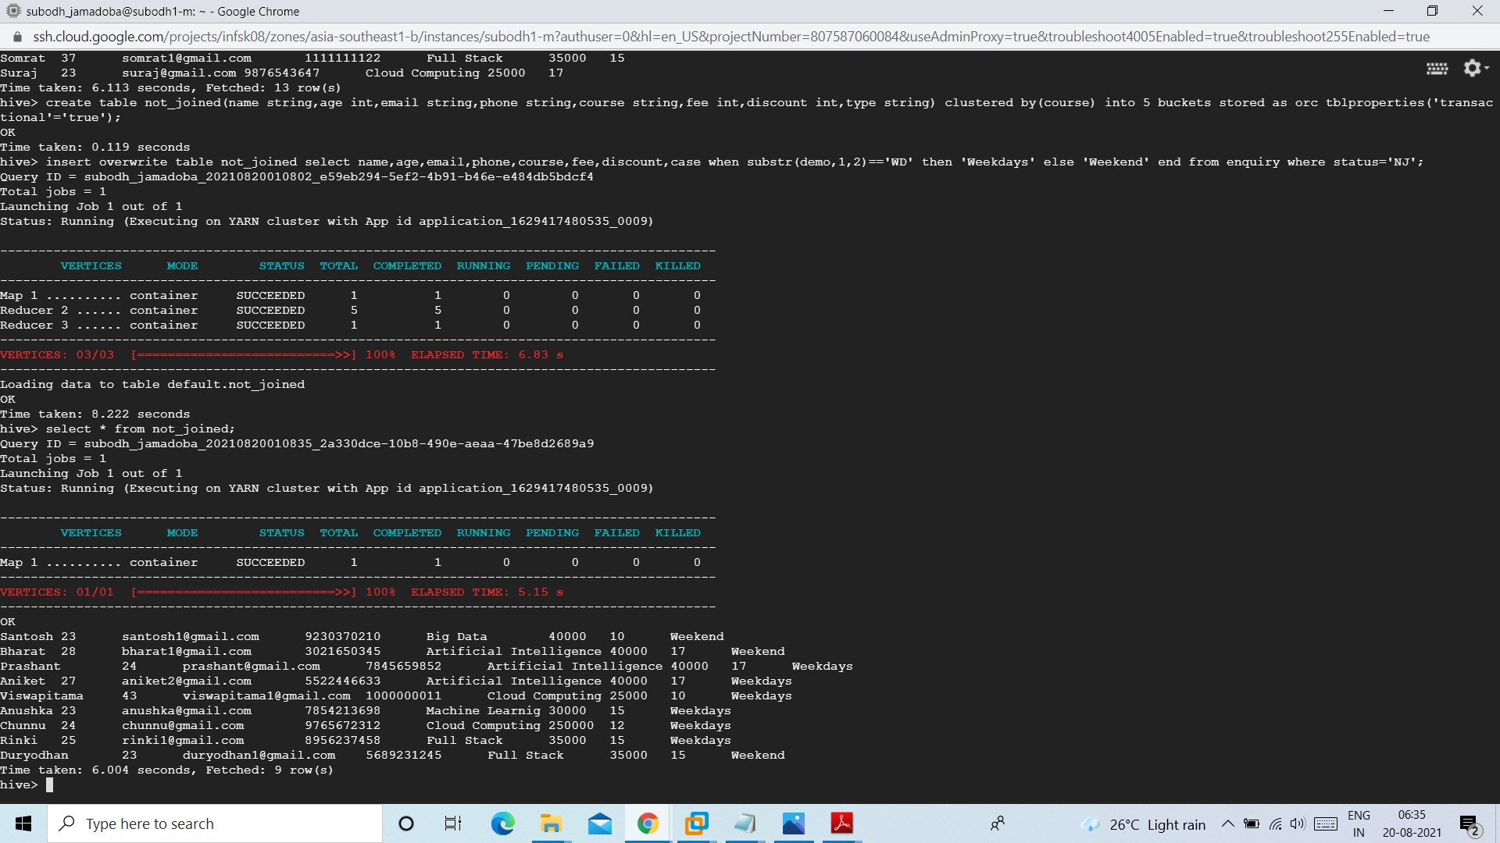

=>create table payment(name string,age int,email string,phone string,course string,type string,fee int) stored as orc tblproperties('transactional'='true');

insert overwrite table payment select name,age,email,phone,course,case when substr(demo,1,2)=='WD' then 'Weekdays' else 'Weekend' end,fee from enquiry where status='EWE' or status='EWD';

Select * from payment;

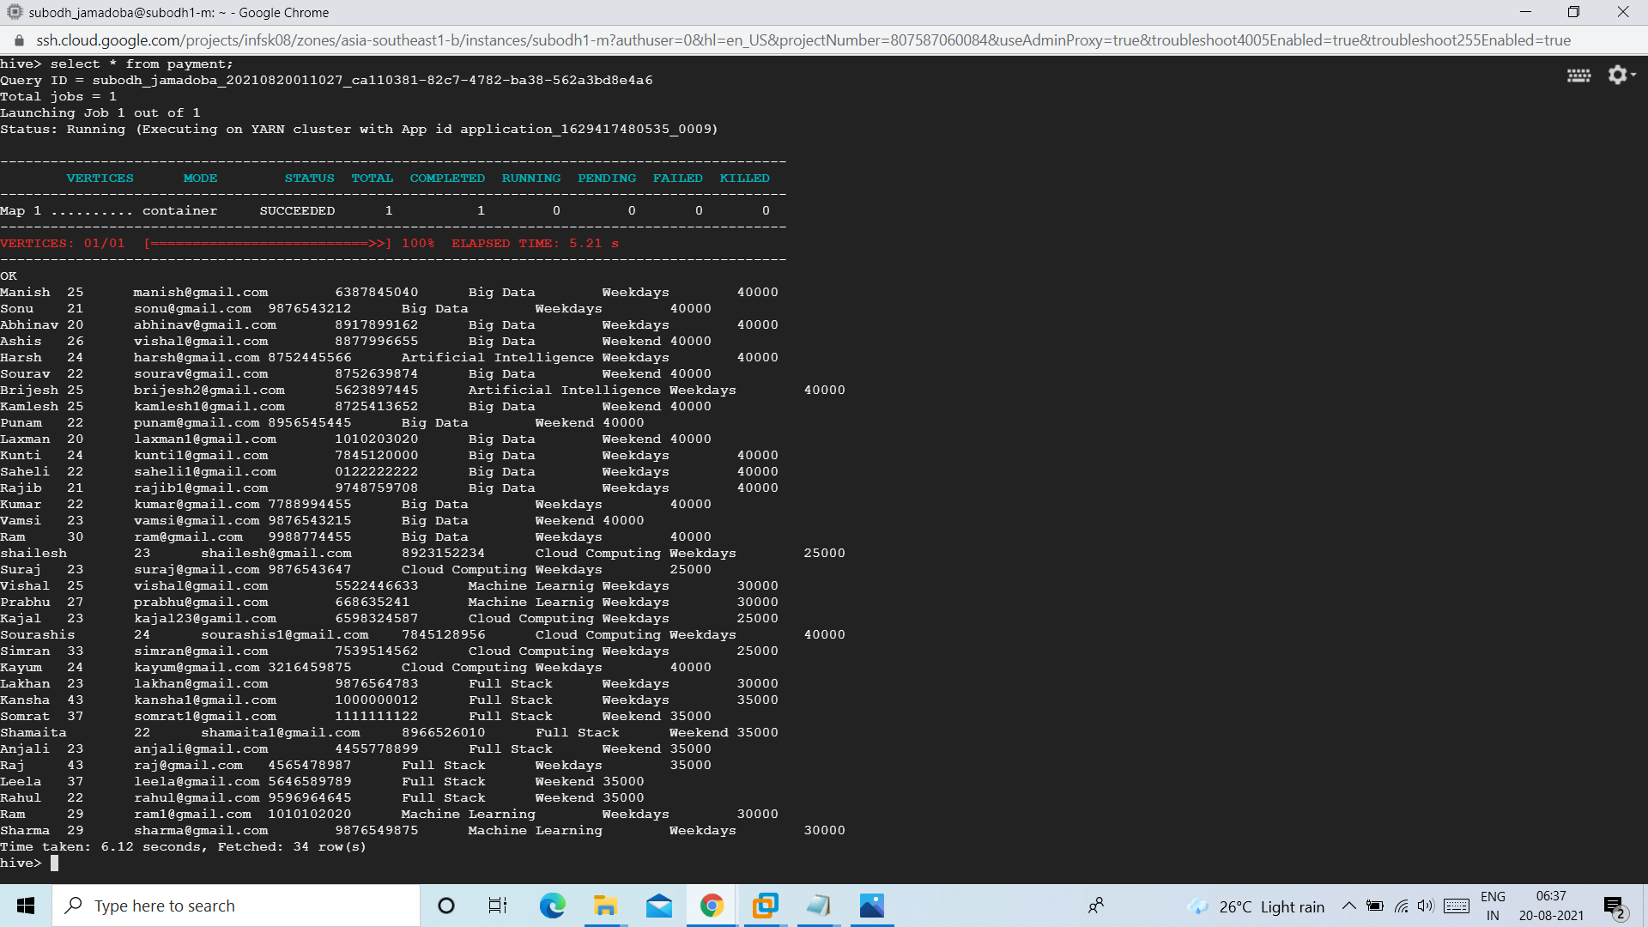

alter table payment add columns(paid int,mode string,no_of_install int,due_date string);

insert overwrite table payment select p.name, p.age, p.email, p.phone, p.course,p.type, p.fee,j.paid,j.mode,j.no_of_install,j.due_date from payment p left join table4 j on p.name=j.name;

insert overwrite table payment select p.name, p.age, p.email, p.phone, p.course,p.type, p.fee,j.paid,j.mode,j.no_of_install,j.due_date from payment p join table4 j on p.name=j.name;

Select * from payment;

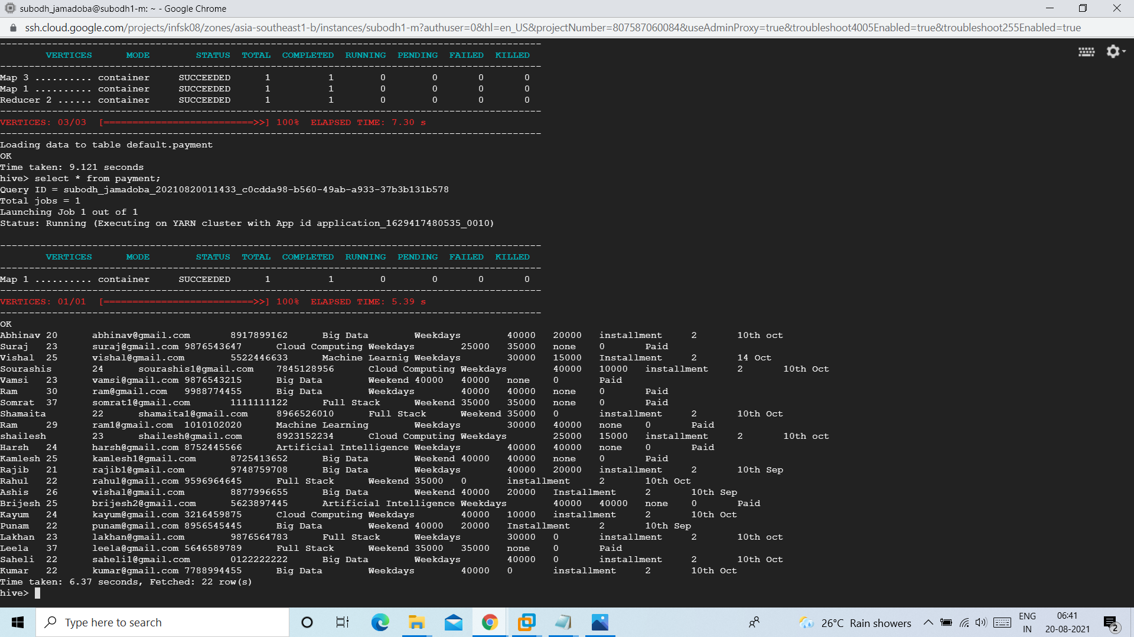

Let’s try to append a record to enquiry table and try to update it :

1. Inserting a new record into enquiry table

insert into table enquiry values("Ramesh",25,"Ramesh@gmail.com",'7869567860','Cloud Computing',25000,10,'WE:SUN:11AM','DND');

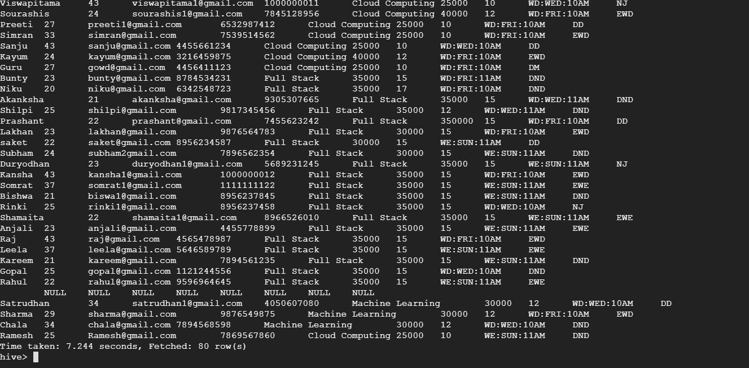

1. Fetching the record into Weekend_demo table

This can be done in two ways – we can insert the new record to our existing table or we can fetch the entire data who scheduled demo on Weekend from enquiry table

insert into table Weekend_demo values("Ramesh",25,"Ramesh@gmail.com",

'7869567860','Cloud Computing','SUN','11AM');

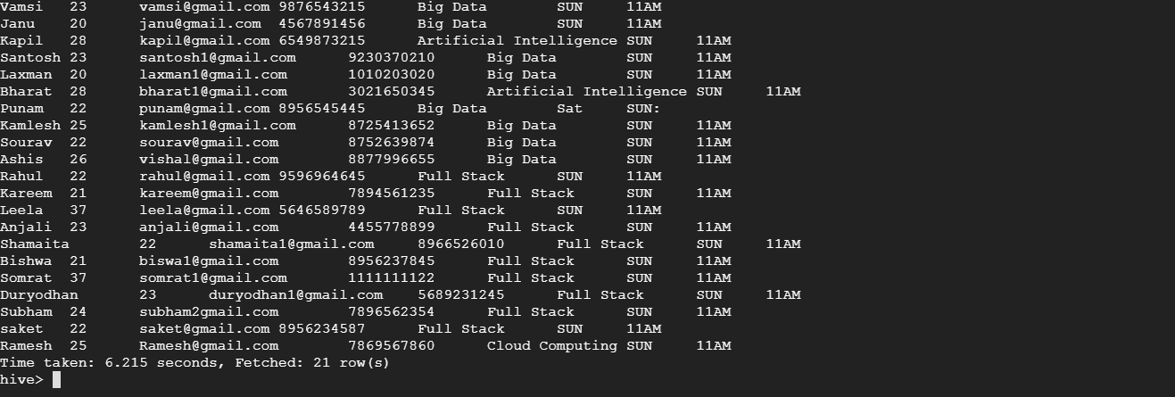

1. Now we assume that the new entry has done with demo and enrolled to Weekend course. We have to update the status to enquiry table

update enquiry set status='EWE' where name='Ramesh';

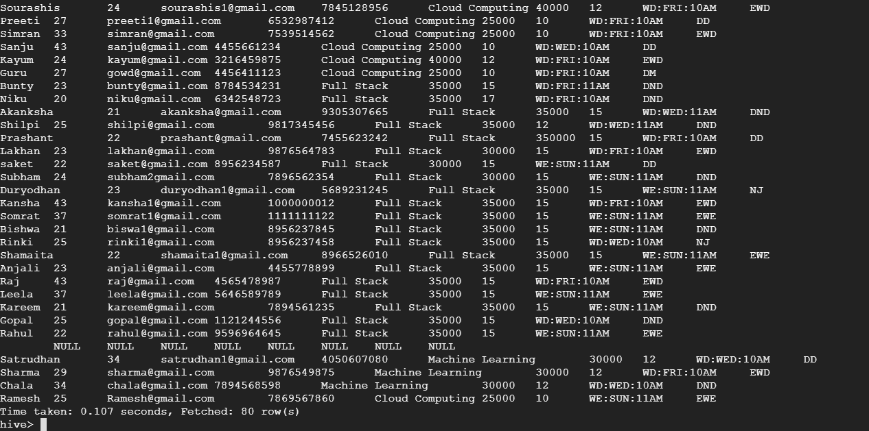

1. As the new entry is done with demo let’s delete the record from Weekend_demo table

delete from Weekend_demo where name='Ramesh';

